3-2 : Tracking Data Changes

1.

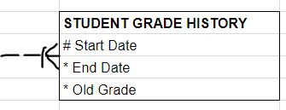

2.

1. Start time part of the UID of Assignment because one Student cannot take two Exams at the same starting time.
2. The Class Room must be assigned before Exam starts.

Exam must be assigned before Start Time.

Exam must be assigned before the event of Exam.